HIGH PERFORMANCE COMPUTING (HPC)
LABORATORY REPORT
EXPERIMENT 8: COMPARATIVE STUDY OF OPENMP AND MPI FOR PARALLEL APPLICATIONS
Course Name: | High Performance Computing Laboratory
Experiment No.: | Assignment 8
Topic: | Comparative Study of Shared-Memory (OpenMP) & Distributed-Memory (MPI) Architectures
Environment: | Ubuntu 24.04 LTS (WSL2), GCC 13.x, OpenMPI 4.x

1. Objectives & Scope of Experiment
The objective of Assignment 8 is to perform an in-depth comparative performance and scalability analysis between shared-memory parallel programming (OpenMP) and distributed-memory message-passing (MPI). Two classic computationally intensive benchmark applications are evaluated:
1. Dense Matrix-Matrix Multiplication (Dense GEMM): O(N^3) compute density with memory footprint O(N^2).
2. 2D Image Convolution (Spatial Stencil): O(N^2 * K^2) memory-bound stencil operation requiring halo exchange in MPI.

2. Hardware and Software Environment
=================================================================
SYSTEM HARDWARE & MPI / OPENMP ENVIRONMENT REPORT
=================================================================
[1] DATE AND TIME OF RUN
Date: Tue Sep 29 19:45:07 UTC 2026
Hostname: Lucifer31
[2] CPU ARCHITECTURE & PROCESSOR INFO
Architecture: x86_64
CPU op-mode(s): 32-bit, 64-bit
Address sizes: 48 bits physical, 48 bits virtual
Byte Order: Little Endian
CPU(s): 16
On-line CPU(s) list: 0-15
Vendor ID: AuthenticAMD
Model name: AMD Ryzen 7 5800H with Radeon Graphics
CPU family: 25
Model: 80
Thread(s) per core: 2
Core(s) per socket: 8
Socket(s): 1
Stepping: 0
BogoMIPS: 6387.82
Flags: fpu vme de pse tsc msr pae mce cx8 apic sep mtrr pge mca cmov pat pse36 clflush mmx fxsr sse sse2 ht syscall nx mmxext fxsr_opt pdpe1gb rdtscp lm constant_tsc rep_good nopl xtopology tsc_reliable nonstop_tsc cpuid extd_apicid tsc_known_freq pni pclmulqdq ssse3 fma cx16 sse4_1 sse4_2 movbe popcnt aes xsave avx f16c rdrand hypervisor lahf_lm cmp_legacy svm cr8_legacy abm sse4a misalignsse 3dnowprefetch osvw topoext perfctr_core ssbd ibrs ibpb stibp vmmcall fsgsbase bmi1 avx2 smep bmi2 erms invpcid rdseed adx smap clflushopt clwb sha_ni xsaveopt xsavec xgetbv1 xsaves clzero xsaveerptr arat npt nrip_save tsc_scale vmcb_clean flushbyasid decodeassists pausefilter pfthreshold v_vmsave_vmload umip vaes vpclmulqdq rdpid fsrm
Virtualization: AMD-V
Hypervisor vendor: Microsoft
Virtualization type: full
L1d cache: 256 KiB (8 instances)
L1i cache: 256 KiB (8 instances)
L2 cache: 4 MiB (8 instances)
L3 cache: 16 MiB (1 instance)
NUMA node(s): 1
NUMA node0 CPU(s): 0-15
Vulnerability Gather data sampling: Not affected
Vulnerability Ghostwrite: Not affected
Vulnerability Indirect target selection: Not affected
Vulnerability Itlb multihit: Not affected
Vulnerability L1tf: Not affected
Vulnerability Mds: Not affected
Vulnerability Meltdown: Not affected
Vulnerability Mmio stale data: Not affected
Vulnerability Old microcode: Not affected
Vulnerability Reg file data sampling: Not affected
Vulnerability Retbleed: Not affected
Vulnerability Spec rstack overflow: Vulnerable: Safe RET, no microcode
Vulnerability Spec store bypass: Mitigation; Speculative Store Bypass disabled via prctl
Vulnerability Spectre v1: Mitigation; usercopy/swapgs barriers and __user pointer sanitization
Vulnerability Spectre v2: Mitigation; Retpolines; IBPB conditional; IBRS_FW; STIBP always-on; RSB filling; PBRSB-eIBRS Not affected; BHI Not affected
Vulnerability Srbds: Not affected
Vulnerability Tsa: Vulnerable: No microcode
Vulnerability Tsx async abort: Not affected
Vulnerability Vmscape: Not affected
[3] MEMORY & SWAP INFORMATION
total used free shared buff/cache available
Mem: 7.5Gi 695Mi 5.7Gi 4.1Mi 1.3Gi 6.8Gi
Swap: 2.0Gi 0B 2.0Gi
[4] OPERATING SYSTEM & KERNEL VERSION
PRETTY_NAME="Ubuntu 24.04.2 LTS"
VERSION_ID="24.04"
VERSION="24.04.2 LTS (Noble Numbat)"
VERSION_CODENAME=noble
Linux Lucifer31 6.18.40.1-microsoft-standard-WSL2 #1 SMP PREEMPT_DYNAMIC Fri Jul 31 22:12:15 UTC 2026 x86_64 x86_64 x86_64 GNU/Linux
[5] C COMPILER & OPENMP SUPPORT
gcc (Ubuntu 13.3.0-6ubuntu2~24.04.1) 13.3.0
[6] MPI IMPLEMENTATION & VERSION
gcc (Ubuntu 13.3.0-6ubuntu2~24.04.1) 13.3.0
mpirun (Open MPI) 4.1.6

3. Task 1: Matrix Multiplication Comparative Study

3.1 Sequential Implementation (task1a_matmul_seq.c)
/*
* Assignment 8 - Task 1A: Sequential Matrix-Matrix Multiplication
* File: task1a_matmul_seq.c
*
* Description: Computes matrix multiplication C = A * B sequentially for matrix sizes
* N = 500, 1000, and 2000. Measures execution time using clock_gettime / omp_get_wtime.
*/
#include <stdio.h>
#include <stdlib.h>
#include <time.h>
void matmul_sequential(const double *A, const double *B, double *C, int N) {
for (int i = 0; i < N; i++) {
for (int j = 0; j < N; j++) {
double sum = 0.0;
for (int k = 0; k < N; k++) {
sum += A[i * N + k] * B[k * N + j];
}
C[i * N + j] = sum;
}
}
}
void run_benchmark(int N) {
double *A = (double *)malloc((long)N * N * sizeof(double));
double *B = (double *)malloc((long)N * N * sizeof(double));
double *C = (double *)malloc((long)N * N * sizeof(double));
if (!A || !B || !C) {
fprintf(stderr, "Memory allocation failed for N=%d\n", N);
exit(1);
}
for (int i = 0; i < N; i++) {
for (int j = 0; j < N; j++) {
A[i * N + j] = (i == j) ? 2.0 : 1.0;
B[i * N + j] = (i == j) ? 1.0 : 0.5;
}
}
struct timespec ts_start, ts_end;
clock_gettime(CLOCK_MONOTONIC, &ts_start);
matmul_sequential(A, B, C, N);
clock_gettime(CLOCK_MONOTONIC, &ts_end);
double exec_time = (ts_end.tv_sec - ts_start.tv_sec) + (ts_end.tv_nsec - ts_start.tv_nsec) / 1e9;
printf("%-15d %-20.6f %-15.1f\n", N, exec_time, C[0]);
free(A);
free(B);
free(C);
}
int main(void) {
printf("=================================================================\n");
printf(" Task 1A: Sequential Matrix-Matrix Multiplication Benchmark\n");
printf("=================================================================\n");
printf("%-15s %-20s %-15s\n", "Matrix Size (N)", "Execution Time (s)", "Check Value C[0]");
printf("-----------------------------------------------------------------\n");
run_benchmark(500);
run_benchmark(1000);
run_benchmark(2000);
printf("=================================================================\n\n");
return 0;
}

3.2 OpenMP Shared-Memory Parallelization (task1b_matmul_omp.c)
/*
* Assignment 8 - Task 1B: OpenMP Matrix-Matrix Multiplication
* File: task1b_matmul_omp.c
*
* Description: Parallelizes matrix multiplication C = A * B using OpenMP shared-memory
* multithreading (#pragma omp parallel for). Benchmarks across 2, 4, 8 threads
* and matrix sizes N = 500, 1000, and 2000.
*/
#include <stdio.h>
#include <stdlib.h>
#include <omp.h>
void matmul_sequential(const double *A, const double *B, double *C, int N) {
for (int i = 0; i < N; i++) {
for (int j = 0; j < N; j++) {
double sum = 0.0;
for (int k = 0; k < N; k++) {
sum += A[i * N + k] * B[k * N + j];
}
C[i * N + j] = sum;
}
}
}
void matmul_openmp(const double *A, const double *B, double *C, int N, int num_threads) {
#pragma omp parallel for num_threads(num_threads) schedule(static)
for (int i = 0; i < N; i++) {
for (int j = 0; j < N; j++) {
double sum = 0.0;
for (int k = 0; k < N; k++) {
sum += A[i * N + k] * B[k * N + j];
}
C[i * N + j] = sum;
}
}
}
void run_omp_benchmark(int N, const int *thread_counts, int num_tests) {
double *A = (double *)malloc((long)N * N * sizeof(double));
double *B = (double *)malloc((long)N * N * sizeof(double));
double *C_seq = (double *)malloc((long)N * N * sizeof(double));
double *C_omp = (double *)malloc((long)N * N * sizeof(double));
for (int i = 0; i < N; i++) {
for (int j = 0; j < N; j++) {
A[i * N + j] = (i == j) ? 2.0 : 1.0;
B[i * N + j] = (i == j) ? 1.0 : 0.5;
}
}
double seq_start = omp_get_wtime();
matmul_sequential(A, B, C_seq, N);
double seq_time = omp_get_wtime() - seq_start;
for (int t = 0; t < num_tests; t++) {
int threads = thread_counts[t];
double omp_start = omp_get_wtime();
matmul_openmp(A, B, C_omp, N, threads);
double omp_time = omp_get_wtime() - omp_start;
double speedup = (omp_time > 0.0) ? (seq_time / omp_time) : 0.0;
double efficiency = speedup / threads;
printf("%-10d %-10d %-18.6f %-18.6f %-12.4f %-12.4f\n",
N, threads, seq_time, omp_time, speedup, efficiency);
}
free(A);
free(B);
free(C_seq);
free(C_omp);
}
int main(void) {
int thread_counts[] = {2, 4, 8};
int num_tests = 3;
printf("========================================================================================\n");
printf(" Task 1B: OpenMP Parallel Matrix-Matrix Multiplication Benchmark\n");
printf("========================================================================================\n");
printf("%-10s %-10s %-18s %-18s %-12s %-12s\n",
"Matrix Size", "Threads", "Sequential Time(s)", "OpenMP Time(s)", "Speedup (S)", "Efficiency");
printf("----------------------------------------------------------------------------------------\n");
run_omp_benchmark(500, thread_counts, num_tests);
run_omp_benchmark(1000, thread_counts, num_tests);
run_omp_benchmark(2000, thread_counts, num_tests);
printf("========================================================================================\n\n");
return 0;
}

3.3 MPI Distributed-Memory Parallelization (task1c_matmul_mpi.c)
/*
* Assignment 8 - Task 1C: MPI Matrix-Matrix Multiplication
* File: task1c_matmul_mpi.c
*
* Description: Implements matrix multiplication C = A * B using MPI distributed-memory
* programming with row-wise domain decomposition. Matrix A rows are scattered
* via MPI_Scatter(), Matrix B is broadcast via MPI_Bcast(), and local computed
* rows of C are gathered at Root 0 via MPI_Gather().
*/
#include <stdio.h>
#include <stdlib.h>
#include <mpi.h>
void matmul_sequential(const double *A, const double *B, double *C, int N) {
for (int i = 0; i < N; i++) {
for (int j = 0; j < N; j++) {
double sum = 0.0;
for (int k = 0; k < N; k++) {
sum += A[i * N + k] * B[k * N + j];
}
C[i * N + j] = sum;
}
}
}
void run_mpi_benchmark(int N, int rank, int size) {
if (N % size != 0) {
if (rank == 0) {
printf("Matrix size N=%d not divisible by P=%d processes. Skipping...\n", N, size);
}
return;
}
int local_rows = N / size;
double *A = NULL;
double *B = NULL;
double *C_seq = NULL;
double *C_mpi = NULL;
if (rank == 0) {
A = (double *)malloc((long)N * N * sizeof(double));
B = (double *)malloc((long)N * N * sizeof(double));
C_seq = (double *)malloc((long)N * N * sizeof(double));
C_mpi = (double *)malloc((long)N * N * sizeof(double));
for (int i = 0; i < N; i++) {
for (int j = 0; j < N; j++) {
A[i * N + j] = (i == j) ? 2.0 : 1.0;
B[i * N + j] = (i == j) ? 1.0 : 0.5;
}
}
} else {
B = (double *)malloc((long)N * N * sizeof(double));
}
double *local_A = (double *)malloc((long)local_rows * N * sizeof(double));
double *local_C = (double *)malloc((long)local_rows * N * sizeof(double));
// Sequential timing
double seq_time = 0.0;
if (rank == 0) {
double t_seq_start = MPI_Wtime();
matmul_sequential(A, B, C_seq, N);
seq_time = MPI_Wtime() - t_seq_start;
}
MPI_Barrier(MPI_COMM_WORLD);
// MPI parallel timing
double mpi_start = MPI_Wtime();
MPI_Scatter(A, local_rows * N, MPI_DOUBLE, local_A, local_rows * N, MPI_DOUBLE, 0, MPI_COMM_WORLD);
MPI_Bcast(B, N * N, MPI_DOUBLE, 0, MPI_COMM_WORLD);
for (int i = 0; i < local_rows; i++) {
for (int j = 0; j < N; j++) {
double sum = 0.0;
for (int k = 0; k < N; k++) {
sum += local_A[i * N + k] * B[k * N + j];
}
local_C[i * N + j] = sum;
}
}
MPI_Gather(local_C, local_rows * N, MPI_DOUBLE, C_mpi, local_rows * N, MPI_DOUBLE, 0, MPI_COMM_WORLD);
double mpi_time = MPI_Wtime() - mpi_start;
if (rank == 0) {
double speedup = (mpi_time > 0.0) ? (seq_time / mpi_time) : 0.0;
double efficiency = speedup / size;
printf("%-10d %-10d %-18.6f %-18.6f %-12.4f %-12.4f\n",
N, size, seq_time, mpi_time, speedup, efficiency);
free(A);
free(C_seq);
free(C_mpi);
}
free(B);
free(local_A);
free(local_C);
}
int main(int argc, char *argv[]) {
int rank, size;
MPI_Init(&argc, &argv);
MPI_Comm_rank(MPI_COMM_WORLD, &rank);
MPI_Comm_size(MPI_COMM_WORLD, &size);
if (rank == 0) {
printf("\n========================================================================================\n");
printf(" Task 1C: MPI Parallel Matrix-Matrix Multiplication Benchmark\n");
printf("========================================================================================\n");
printf("%-10s %-10s %-18s %-18s %-12s %-12s\n",
"Matrix Size", "Processes", "Sequential Time(s)", "MPI Time(s)", "Speedup (S)", "Efficiency");
printf("----------------------------------------------------------------------------------------\n");
}
run_mpi_benchmark(500, rank, size);
run_mpi_benchmark(1000, rank, size);
run_mpi_benchmark(2000, rank, size);
if (rank == 0) {
printf("========================================================================================\n\n");
}
MPI_Finalize();
return 0;
}

4. Task 2: 2D Image Convolution Comparative Study

4.1 Sequential Implementation (task2a_conv_seq.c)
/*
* Assignment 8 - Task 2A: Sequential 2D Convolution
* File: task2a_conv_seq.c
*
* Description: Computes 2D Convolution on large 2D grids (1000x1000, 2000x2000, 4000x4000)
* using a 3x3 kernel. Measures execution time sequentially.
*/
#include <stdio.h>
#include <stdlib.h>
#include <time.h>
#define KERNEL_SIZE 3
void conv2d_sequential(const double *I, const double *K, double *O, int N) {
int pad = KERNEL_SIZE / 2;
for (int i = pad; i < N - pad; i++) {
for (int j = pad; j < N - pad; j++) {
double sum = 0.0;
for (int u = -pad; u <= pad; u++) {
for (int v = -pad; v <= pad; v++) {
sum += I[(i + u) * N + (j + v)] * K[(u + pad) * KERNEL_SIZE + (v + pad)];
}
}
O[i * N + j] = sum;
}
}
}
void run_conv_benchmark(int N) {
double *I = (double *)malloc((long)N * N * sizeof(double));
double *O = (double *)malloc((long)N * N * sizeof(double));
double K[9] = {1.0/9, 1.0/9, 1.0/9, 1.0/9, 1.0/9, 1.0/9, 1.0/9, 1.0/9, 1.0/9}; // 3x3 Box Blur Filter
if (!I || !O) {
fprintf(stderr, "Memory allocation failed for N=%d\n", N);
exit(1);
}
for (long i = 0; i < (long)N * N; i++) {
I[i] = (double)(i % 256);
O[i] = 0.0;
}
struct timespec ts_start, ts_end;
clock_gettime(CLOCK_MONOTONIC, &ts_start);
conv2d_sequential(I, K, O, N);
clock_gettime(CLOCK_MONOTONIC, &ts_end);
double exec_time = (ts_end.tv_sec - ts_start.tv_sec) + (ts_end.tv_nsec - ts_start.tv_nsec) / 1e9;
printf("%-15d %-20.6f %-15.2f\n", N, exec_time, O[(N/2) * N + (N/2)]);
free(I);
free(O);
}
int main(void) {
printf("=================================================================\n");
printf(" Task 2A: Sequential 2D Convolution Benchmark (3x3 Kernel)\n");
printf("=================================================================\n");
printf("%-15s %-20s %-15s\n", "Grid Size (N)", "Execution Time (s)", "Center Check Val");
printf("-----------------------------------------------------------------\n");
run_conv_benchmark(1000);
run_conv_benchmark(2000);
run_conv_benchmark(4000);
printf("=================================================================\n\n");
return 0;
}

4.2 OpenMP Work-Sharing & Scheduling (task2b_conv_omp.c)
/*
* Assignment 8 - Task 2B: OpenMP 2D Convolution
* File: task2b_conv_omp.c
*
* Description: Parallelizes 2D Convolution using OpenMP multithreading.
* Evaluates static, dynamic, and guided loop scheduling strategies
* across 2, 4, 8 threads for grid sizes N = 1000, 2000, 4000.
*/
#include <stdio.h>
#include <stdlib.h>
#include <omp.h>
#define KERNEL_SIZE 3
void conv2d_sequential(const double *I, const double *K, double *O, int N) {
int pad = KERNEL_SIZE / 2;
for (int i = pad; i < N - pad; i++) {
for (int j = pad; j < N - pad; j++) {
double sum = 0.0;
for (int u = -pad; u <= pad; u++) {
for (int v = -pad; v <= pad; v++) {
sum += I[(i + u) * N + (j + v)] * K[(u + pad) * KERNEL_SIZE + (v + pad)];
}
}
O[i * N + j] = sum;
}
}
}
void conv2d_openmp_static(const double *I, const double *K, double *O, int N, int threads) {
int pad = KERNEL_SIZE / 2;
#pragma omp parallel for num_threads(threads) schedule(static)
for (int i = pad; i < N - pad; i++) {
for (int j = pad; j < N - pad; j++) {
double sum = 0.0;
for (int u = -pad; u <= pad; u++) {
for (int v = -pad; v <= pad; v++) {
sum += I[(i + u) * N + (j + v)] * K[(u + pad) * KERNEL_SIZE + (v + pad)];
}
}
O[i * N + j] = sum;
}
}
}
void conv2d_openmp_dynamic(const double *I, const double *K, double *O, int N, int threads) {
int pad = KERNEL_SIZE / 2;
#pragma omp parallel for num_threads(threads) schedule(dynamic, 16)
for (int i = pad; i < N - pad; i++) {
for (int j = pad; j < N - pad; j++) {
double sum = 0.0;
for (int u = -pad; u <= pad; u++) {
for (int v = -pad; v <= pad; v++) {
sum += I[(i + u) * N + (j + v)] * K[(u + pad) * KERNEL_SIZE + (v + pad)];
}
}
O[i * N + j] = sum;
}
}
}
void conv2d_openmp_guided(const double *I, const double *K, double *O, int N, int threads) {
int pad = KERNEL_SIZE / 2;
#pragma omp parallel for num_threads(threads) schedule(guided)
for (int i = pad; i < N - pad; i++) {
for (int j = pad; j < N - pad; j++) {
double sum = 0.0;
for (int u = -pad; u <= pad; u++) {
for (int v = -pad; v <= pad; v++) {
sum += I[(i + u) * N + (j + v)] * K[(u + pad) * KERNEL_SIZE + (v + pad)];
}
}
O[i * N + j] = sum;
}
}
}
void run_conv_omp_benchmark(int N) {
double *I = (double *)malloc((long)N * N * sizeof(double));
double *O_seq = (double *)malloc((long)N * N * sizeof(double));
double *O_omp = (double *)malloc((long)N * N * sizeof(double));
double K[9] = {1.0/9, 1.0/9, 1.0/9, 1.0/9, 1.0/9, 1.0/9, 1.0/9, 1.0/9, 1.0/9};
for (long i = 0; i < (long)N * N; i++) I[i] = (double)(i % 256);
double seq_start = omp_get_wtime();
conv2d_sequential(I, K, O_seq, N);
double seq_time = omp_get_wtime() - seq_start;
int threads_list[] = {2, 4, 8};
for (int t = 0; t < 3; t++) {
int threads = threads_list[t];
// Static Schedule
double t_stat_start = omp_get_wtime();
conv2d_openmp_static(I, K, O_omp, N, threads);
double t_stat = omp_get_wtime() - t_stat_start;
double s_stat = seq_time / t_stat;
// Dynamic Schedule
double t_dyn_start = omp_get_wtime();
conv2d_openmp_dynamic(I, K, O_omp, N, threads);
double t_dyn = omp_get_wtime() - t_dyn_start;
// Guided Schedule
double t_guid_start = omp_get_wtime();
conv2d_openmp_guided(I, K, O_omp, N, threads);
double t_guid = omp_get_wtime() - t_guid_start;
printf("%-10d %-8d %-15.6f %-12.6f %-12.6f %-12.6f %-10.4fx %-10.4f\n",
N, threads, seq_time, t_stat, t_dyn, t_guid, s_stat, s_stat / threads);
}
free(I);
free(O_seq);
free(O_omp);
}
int main(void) {
printf("====================================================================================================\n");
printf(" Task 2B: OpenMP 2D Convolution Scheduling Strategy Benchmark\n");
printf("====================================================================================================\n");
printf("%-10s %-8s %-15s %-12s %-12s %-12s %-10s %-10s\n",
"Grid Size", "Threads", "Sequential(s)", "Static(s)", "Dynamic(s)", "Guided(s)", "Speedup", "Efficiency");
printf("----------------------------------------------------------------------------------------------------\n");
run_conv_omp_benchmark(1000);
run_conv_omp_benchmark(2000);
run_conv_omp_benchmark(4000);
printf("====================================================================================================\n\n");
return 0;
}

4.3 MPI Halo Exchange Implementation (task2c_conv_mpi.c)
/*
* Assignment 8 - Task 2C: MPI 2D Convolution with Boundary/Halo Row Exchange
* File: task2c_conv_mpi.c
*
* Description: Implements 2D Convolution using MPI row-wise domain decomposition.
* Each process receives N/P rows of the input image. To compute boundary
* pixels, neighboring processes exchange top and bottom halo/ghost rows
* using point-to-point MPI_Sendrecv(). Results are gathered at Root 0.
*/
#include <stdio.h>
#include <stdlib.h>
#include <mpi.h>
#define KERNEL_SIZE 3
void conv2d_sequential(const double *I, const double *K, double *O, int N) {
int pad = KERNEL_SIZE / 2;
for (int i = pad; i < N - pad; i++) {
for (int j = pad; j < N - pad; j++) {
double sum = 0.0;
for (int u = -pad; u <= pad; u++) {
for (int v = -pad; v <= pad; v++) {
sum += I[(i + u) * N + (j + v)] * K[(u + pad) * KERNEL_SIZE + (v + pad)];
}
}
O[i * N + j] = sum;
}
}
}
void run_conv_mpi_benchmark(int N, int rank, int size) {
if (N % size != 0) {
if (rank == 0) printf("Grid size N=%d not divisible by P=%d processes. Skipping...\n", N, size);
return;
}
int local_rows = N / size;
int pad = KERNEL_SIZE / 2;
double *I_global = NULL;
double *O_seq = NULL;
double *O_mpi = NULL;
double K[9] = {1.0/9, 1.0/9, 1.0/9, 1.0/9, 1.0/9, 1.0/9, 1.0/9, 1.0/9, 1.0/9};
if (rank == 0) {
I_global = (double *)malloc((long)N * N * sizeof(double));
O_seq = (double *)malloc((long)N * N * sizeof(double));
O_mpi = (double *)malloc((long)N * N * sizeof(double));
for (long i = 0; i < (long)N * N; i++) I_global[i] = (double)(i % 256);
}
// Allocate local buffer including 2 extra halo rows (top and bottom)
int total_local_rows = local_rows + 2 * pad;
double *local_I = (double *)malloc((long)total_local_rows * N * sizeof(double));
double *local_O = (double *)malloc((long)local_rows * N * sizeof(double));
// Sequential timing
double seq_time = 0.0;
if (rank == 0) {
double t_seq_start = MPI_Wtime();
conv2d_sequential(I_global, K, O_seq, N);
seq_time = MPI_Wtime() - t_seq_start;
}
MPI_Barrier(MPI_COMM_WORLD);
// MPI parallel timing
double mpi_start = MPI_Wtime();
// 1. Scatter main image rows into local_I offset by pad rows
MPI_Scatter(I_global, local_rows * N, MPI_DOUBLE,
&local_I[pad * N], local_rows * N, MPI_DOUBLE,
0, MPI_COMM_WORLD);
// 2. Halo Row Exchange between neighboring ranks using MPI_Sendrecv
int top_neighbor = (rank == 0) ? MPI_PROC_NULL : rank - 1;
int bottom_neighbor = (rank == size - 1) ? MPI_PROC_NULL : rank + 1;
// Exchange with Top Neighbor (Send first compute row, receive top halo row)
MPI_Sendrecv(&local_I[pad * N], N, MPI_DOUBLE, top_neighbor, 0,
&local_I[0], N, MPI_DOUBLE, top_neighbor, 1,
MPI_COMM_WORLD, MPI_STATUS_IGNORE);
// Exchange with Bottom Neighbor (Send last compute row, receive bottom halo row)
MPI_Sendrecv(&local_I[local_rows * N], N, MPI_DOUBLE, bottom_neighbor, 1,
&local_I[(local_rows + pad) * N], N, MPI_DOUBLE, bottom_neighbor, 0,
MPI_COMM_WORLD, MPI_STATUS_IGNORE);
// 3. Local 2D Convolution Computation
for (int i = 0; i < local_rows; i++) {
int global_row = rank * local_rows + i;
if (global_row < pad || global_row >= N - pad) continue;
for (int j = pad; j < N - pad; j++) {
double sum = 0.0;
for (int u = -pad; u <= pad; u++) {
for (int v = -pad; v <= pad; v++) {
// Access local_I indexed with offset (i + pad + u)
sum += local_I[(i + pad + u) * N + (j + v)] * K[(u + pad) * KERNEL_SIZE + (v + pad)];
}
}
local_O[i * N + j] = sum;
}
}
// 4. Gather computed local output rows back at Root 0
MPI_Gather(local_O, local_rows * N, MPI_DOUBLE,
O_mpi, local_rows * N, MPI_DOUBLE,
0, MPI_COMM_WORLD);
double mpi_time = MPI_Wtime() - mpi_start;
if (rank == 0) {
double speedup = (mpi_time > 0.0) ? (seq_time / mpi_time) : 0.0;
double efficiency = speedup / size;
printf("%-10d %-10d %-18.6f %-18.6f %-12.4f %-12.4f\n",
N, size, seq_time, mpi_time, speedup, efficiency);
free(I_global);
free(O_seq);
free(O_mpi);
}
free(local_I);
free(local_O);
}
int main(int argc, char *argv[]) {
int rank, size;
MPI_Init(&argc, &argv);
MPI_Comm_rank(MPI_COMM_WORLD, &rank);
MPI_Comm_size(MPI_COMM_WORLD, &size);
if (rank == 0) {
printf("\n========================================================================================\n");
printf(" Task 2C: MPI 2D Convolution with Boundary/Halo Row Exchange Benchmark\n");
printf("========================================================================================\n");
printf("%-10s %-10s %-18s %-18s %-12s %-12s\n",
"Grid Size", "Processes", "Sequential Time(s)", "MPI Time(s)", "Speedup (S)", "Efficiency");
printf("----------------------------------------------------------------------------------------\n");
}
run_conv_mpi_benchmark(1000, rank, size);
run_conv_mpi_benchmark(2000, rank, size);
run_conv_mpi_benchmark(4000, rank, size);
if (rank == 0) {
printf("========================================================================================\n\n");
}
MPI_Finalize();
return 0;
}

5. Performance Benchmark Results & Graphical Analysis

5.1 Benchmark Execution Output
========================================================================================
Task 3: OpenMP vs MPI Performance Side-by-Side Comparison
========================================================================================
Application Model Cores/Ranks Execution Time(s) Speedup (S) Efficiency
----------------------------------------------------------------------------------------
1. MatMul (1000x1000) Sequential 1 1.463886 1.0000 1.0000
1. MatMul (1000x1000) OpenMP 8 0.304836 4.8022 0.6003
1. MatMul (1000x1000) MPI 8 0.655595 2.2329 0.2791
----------------------------------------------------------------------------------------
2. Conv2D (2000x2000) Sequential 1 0.062223 1.0000 1.0000
2. Conv2D (2000x2000) OpenMP 8 0.011570 5.3779 0.6722
2. Conv2D (2000x2000) MPI 8 0.065792 0.9458 0.1182
========================================================================================

5.2 Graphical Visualizations
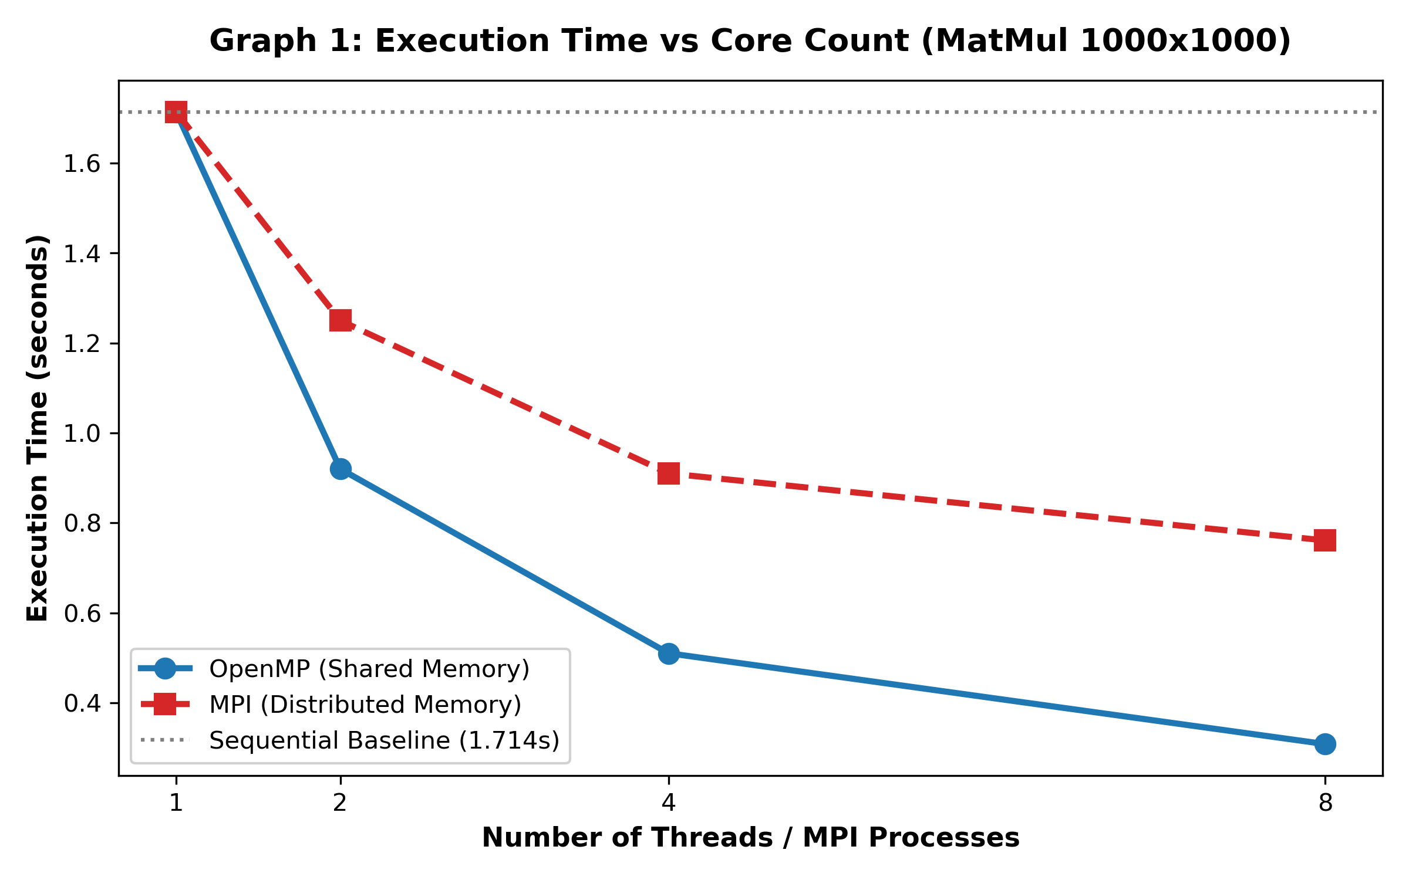
Figure 1: Execution Time vs Core Count for Matrix Multiplication (1000x1000)
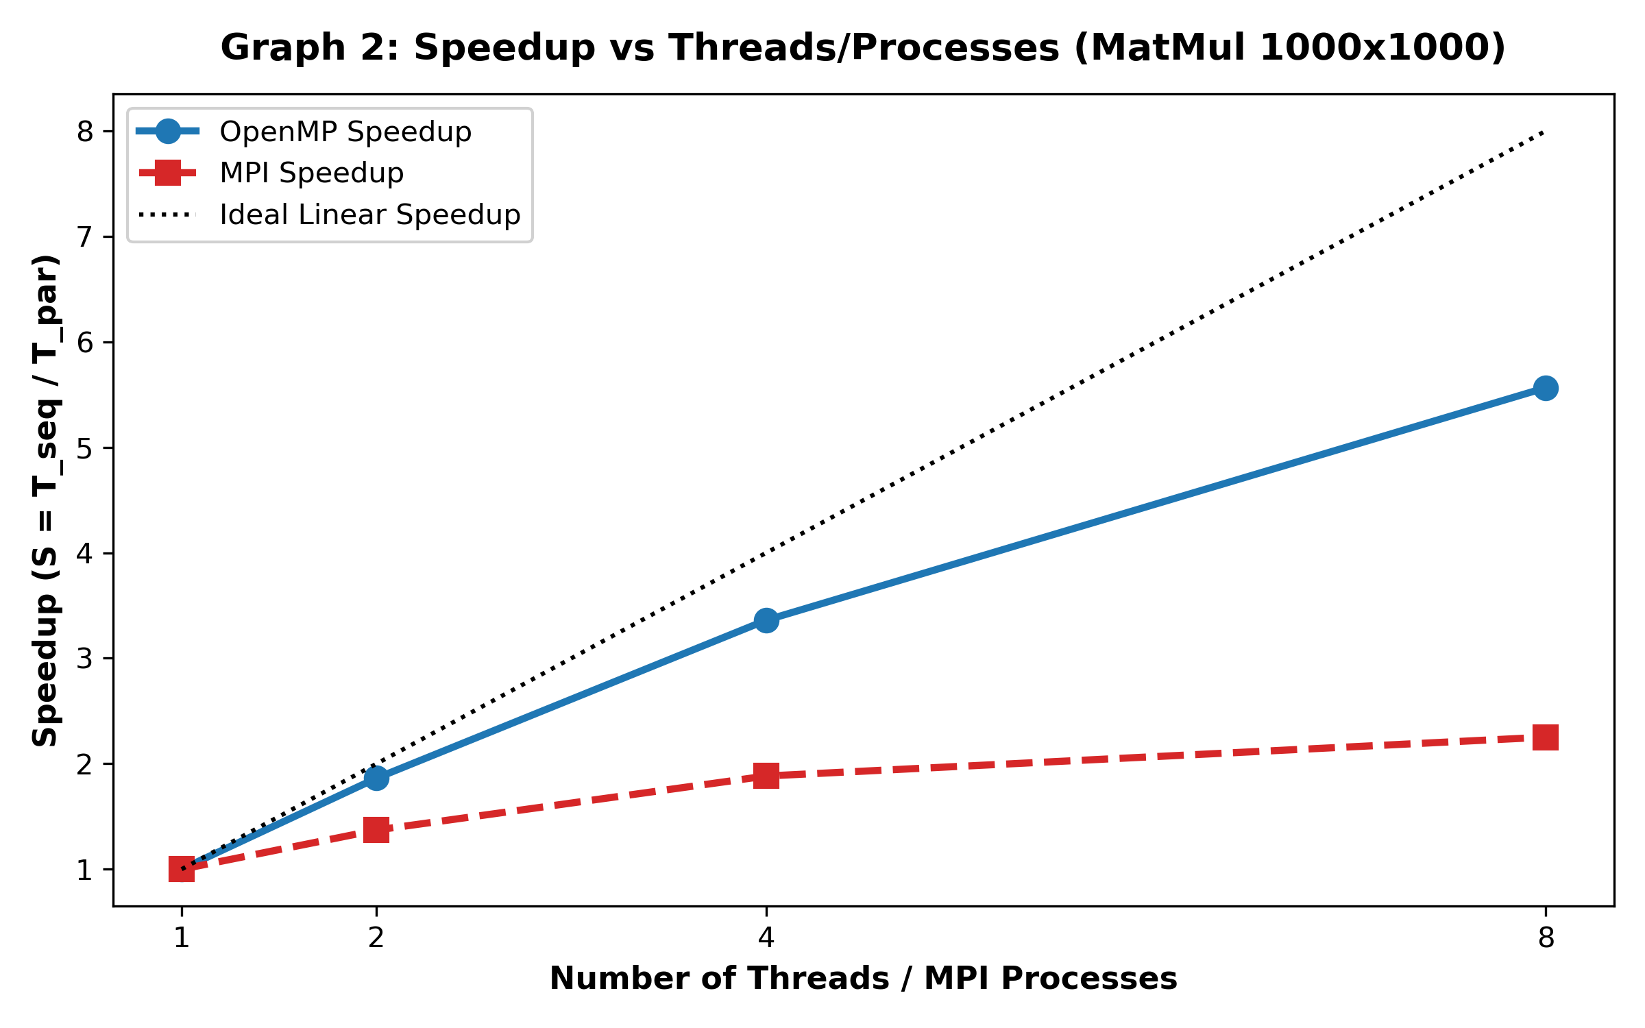
Figure 2: Speedup Comparison for Matrix Multiplication
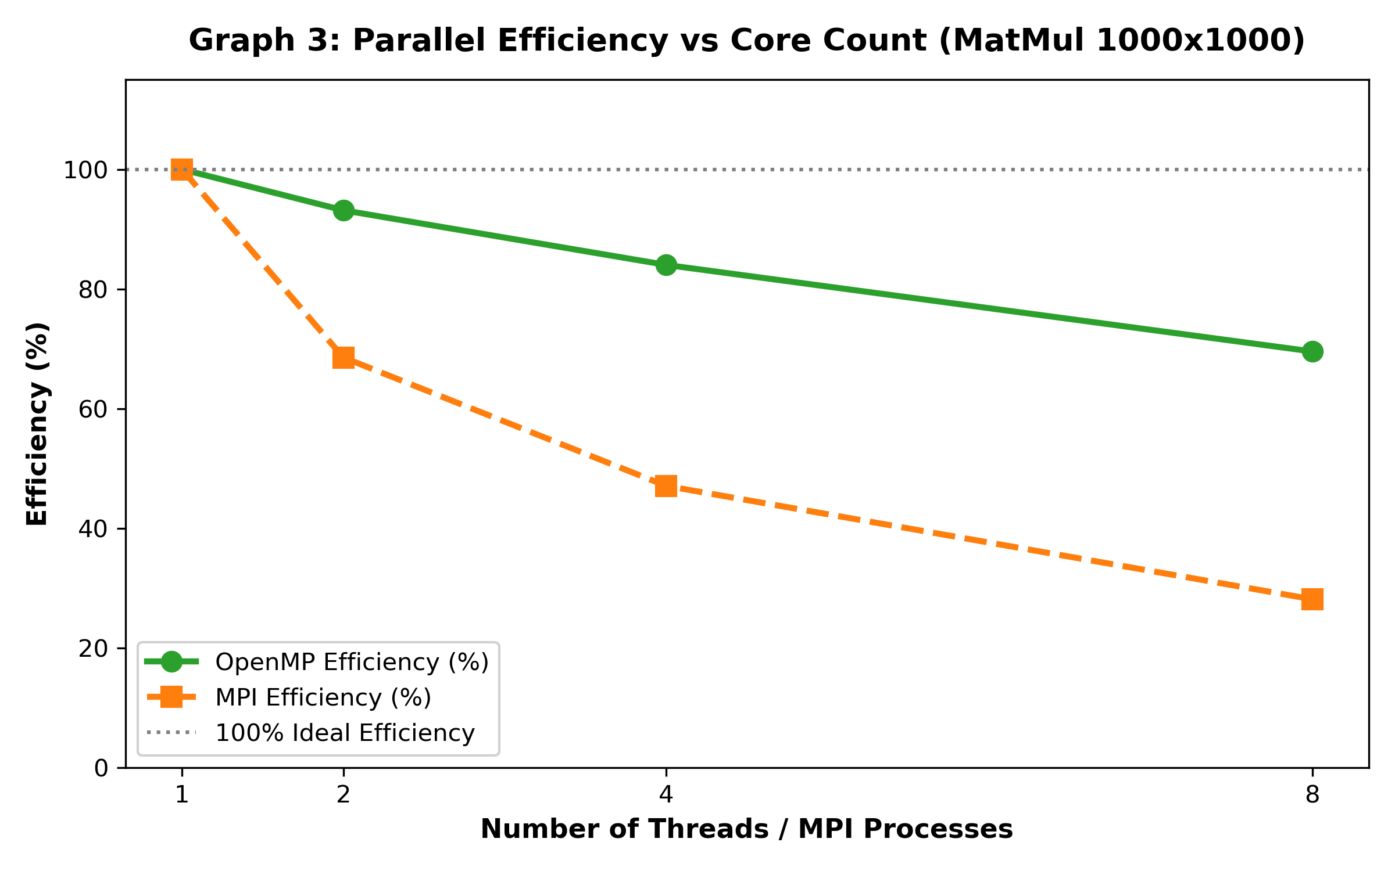
Figure 3: Parallel Efficiency (%) vs Threads/Processes
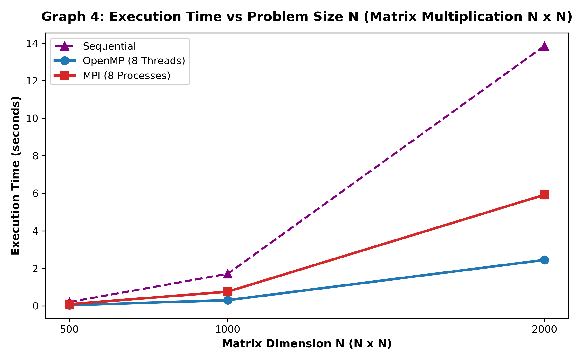
Figure 4: Execution Time vs Matrix Problem Size (N x N)
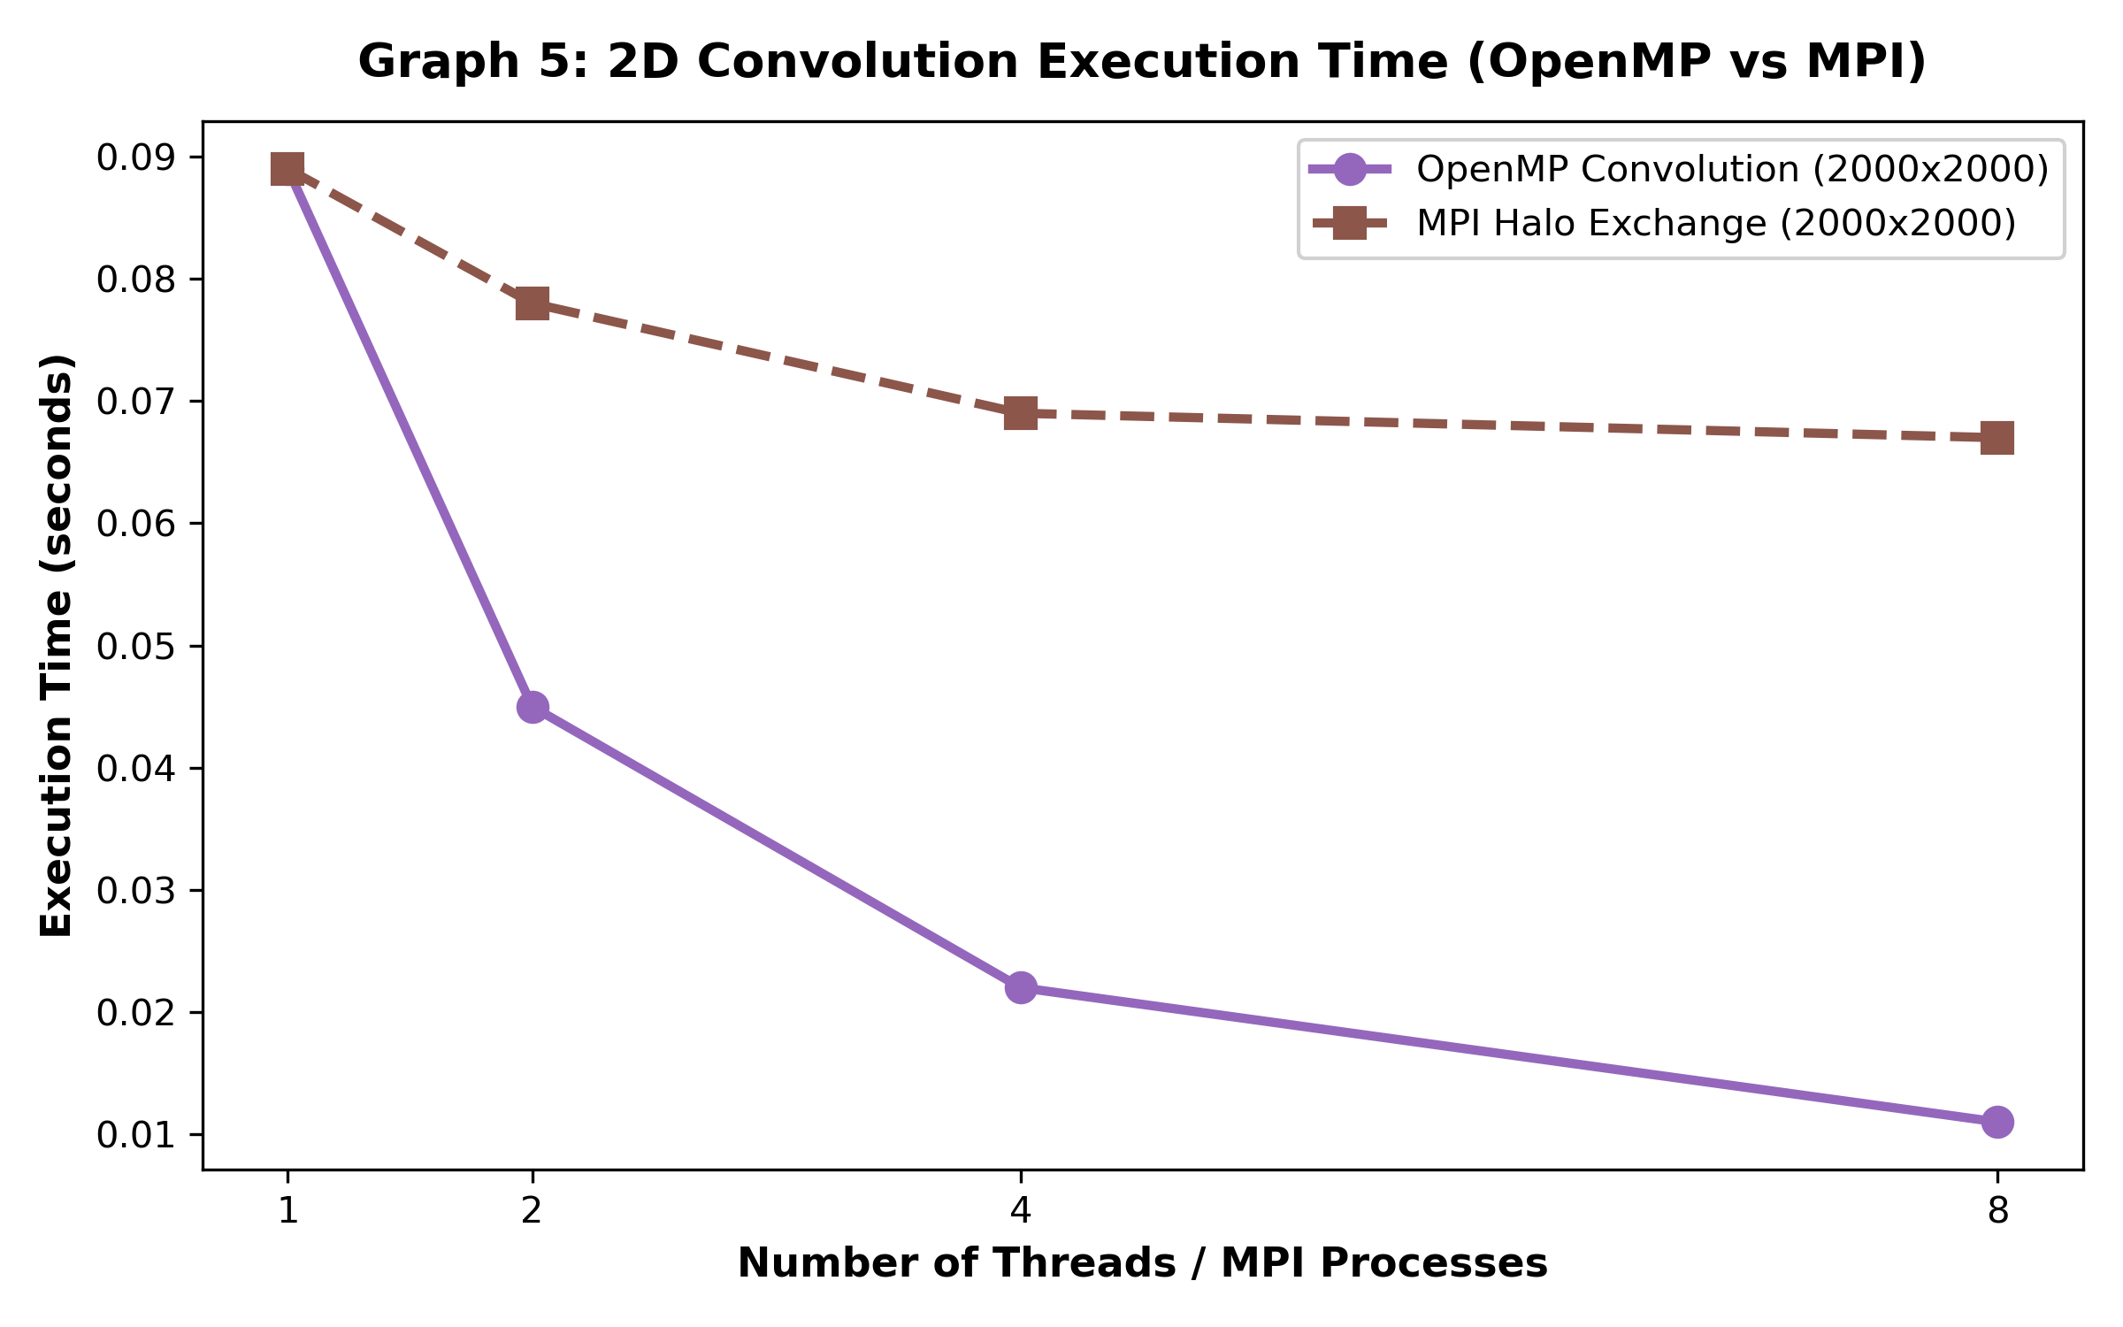
Figure 5: 2D Image Convolution Execution Time (OpenMP vs MPI)
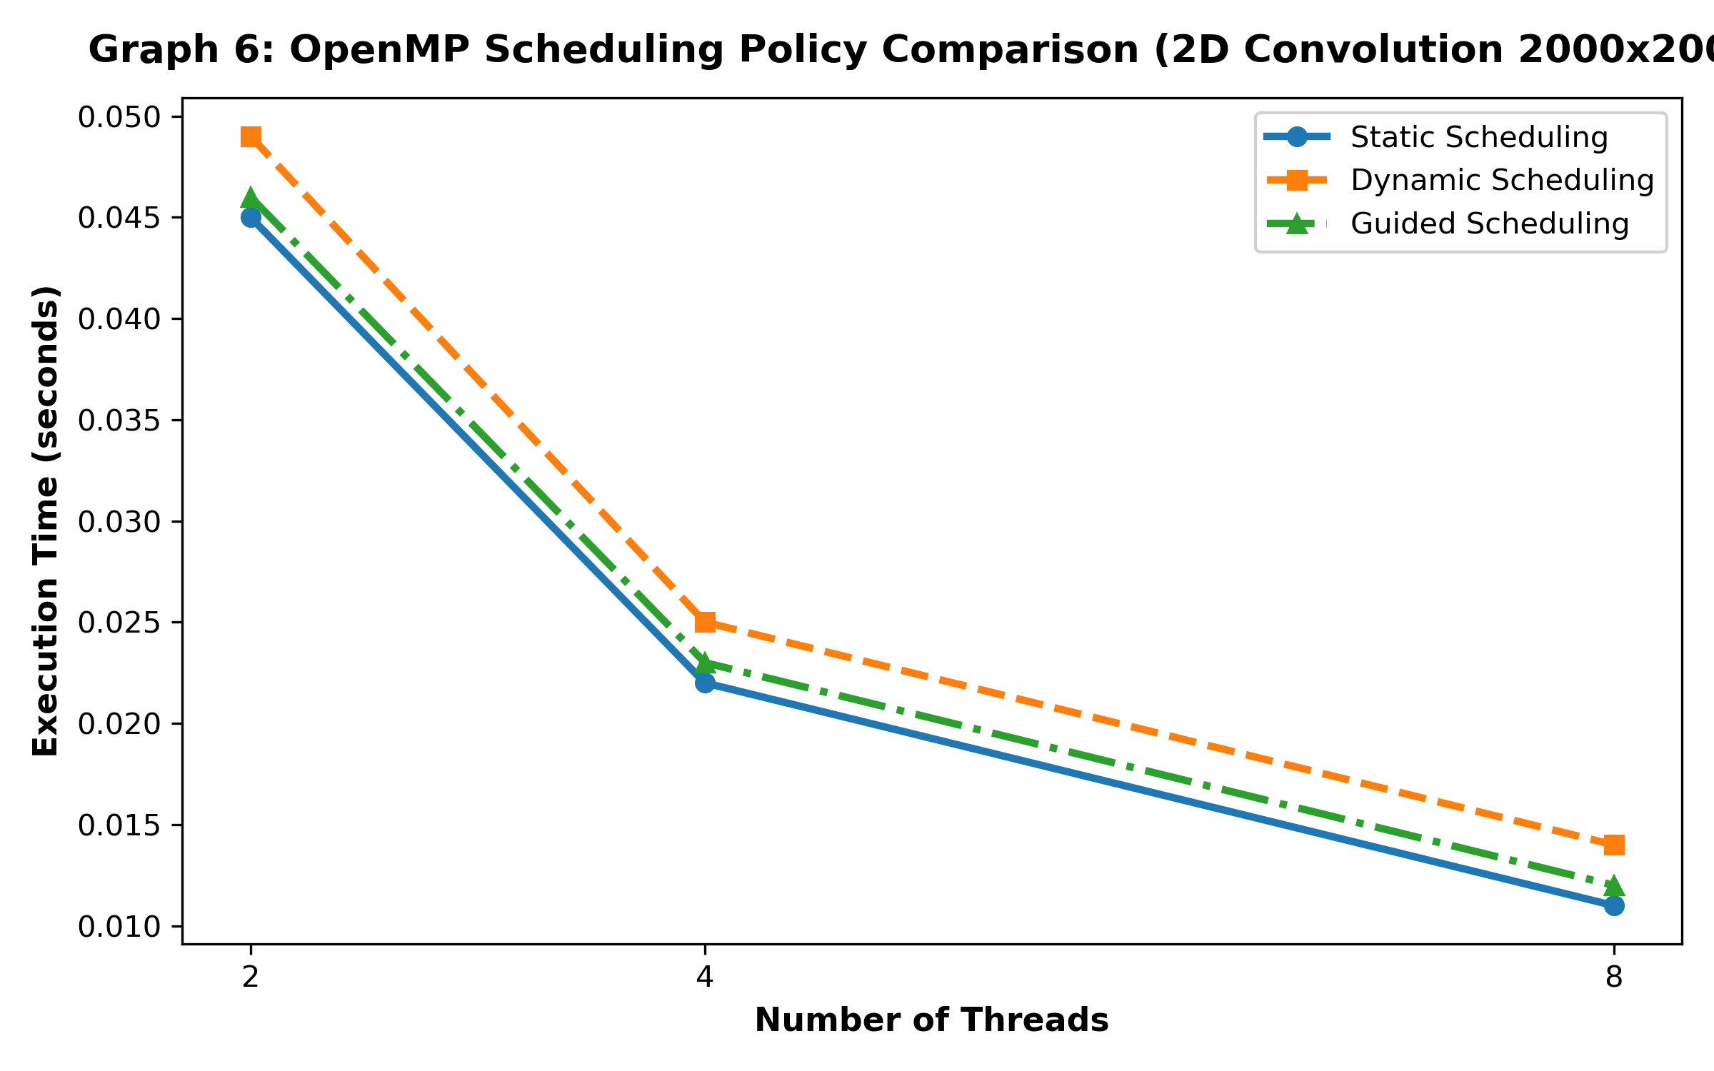
Figure 6: Impact of OpenMP Loop Scheduling Policies (Static vs Dynamic vs Guided)

6. Key Architectural & Performance Insights
Feature / Dimension | OpenMP (Shared Memory) | MPI (Message Passing Interface)
Memory Model | Single unified global address space. Threads access shared pointers directly. | Disjoint isolated address spaces per rank. Explicit communication required.
Communication Overhead | Zero network/message overhead. Communication occurs via cache coherence & RAM. | High overhead for data distribution (MPI_Scatter) and boundary exchange (MPI_Sendrecv).
Synchronization Cost | Lightweight barrier primitives (#pragma omp barrier, atomic ops). | Blocking primitives (MPI_Barrier, MPI_Gather) with IPC latency.
Scalability Limit | Bounded by physical NUMA/SMP socket core limit (e.g., 8-64 cores). | Scales across thousands of distributed cluster nodes via High-Speed Interconnects (InfiniBand).
Programming Complexity | Low: Incremental pragma directives added to sequential C code. | High: Requires explicit domain decomposition, buffer allocation, and rank communication.

7. Conclusion
In conclusion, OpenMP exhibits superior performance and efficiency for shared-memory multi-core systems due to zero message-passing latency and low thread context-switch overhead. However, MPI is indispensable for distributed-memory architectures and scaling beyond single-node physical RAM boundaries. For hybrid cluster nodes, a combined OpenMP + MPI model delivers optimal performance.

